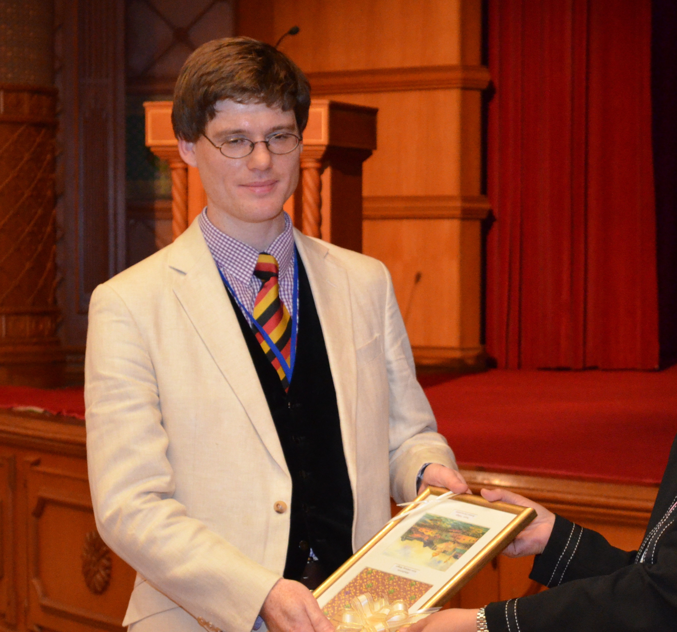

Dr. David A. Clifton

Group Leader - Computational Health Informatics (CHI) Laboratory
Institute of Biomedical Engineering, University of Oxford
Governing Body Fellow of Balliol College

Dr. David Clifton is a tenure-track member of faculty in the Department of Engineering Science of the University of Oxford, and a Governing Body fellow of Balliol College, Oxford. He is a Research Fellow of the Royal Academy of Engineering. A graduate of the University of Oxford, Dr Clifton trained in information engineering and founded the Computational Health Informatics (CHI) lab when we was appointed to the faculty in 2013. His research includes "big data" and mobile health projects, where systems derived from his research are used to monitor over 20,000 patients every month in the UK National Health Service (NHS). His previous work includes the world's first (and, so far, only) FDA-approved multivariate patient monitoring system based on machine learning, and where his related "health monitoring" systems are used on the engines of the Airbus A380, Boeing 787 Dreamliner, and Eurofighter Typhoon.

